MINT Boxes

for upper secondary level
with the MINT cooperation companies

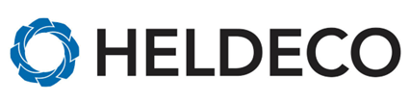

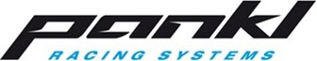

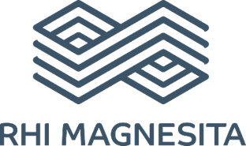

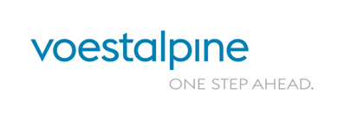

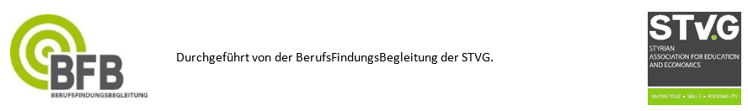

Heldeco CAD/CAM Fertigungstechnik GmbH

Address: Döllach 50, 8624 Aflenz
Contact:
Phone number:
Email:
Website: www.heldeco.at

What does our company do?
Highest precision and accuracy are a prerequisite in CNC technology in order to be able to produce workpieces for the aircraft, hydropower, food, heavy industry and much more. Heldeco is one of Europe's leading manufacturers of sophisticated system solutions, ready-to-install components and complex spare parts in OEM quality. With our modern machines and systems, we specialize in high-end requirements, maximum quality and large-dimensional components with a length of up to 12 meters – under certain conditions even up to 20 meters – and a unit weight of 30 tons.

Pankl Racing Systems AG

Address: Pankl Academy, High-Tech-Park West 1, 8605 Kapfenberg
Contact:
Phone number:
Email:
Website: www.pankl.com

What does our company do?
Pankl Racing Systems develops, produces and sells high-tech components for the motorsport, sports car and aerospace sectors. Together with our customers, our employees and apprentices play a key role in shaping the future of mobility.

RHI Magnesita – Veitsch Plant

Address: RHI Magnesita, Veitsch plant, Magnesitgasse 2, 8664 St. Barbara
Contact:
Phone number:
Email:
Website: www.rhimagnesita.com

What does our company do?
RHI Magnesita is the world market leader in the refractory sector. We have the most locations in the world and the most innovative, reliable products and services. We offer the most robust supply and quality assurance across mining, production and full-fledged service solutions.
Our products are used in the steel, cement and glass industries and serve as the basis for their production.

voestalpine Metal Engineering Division

Address: Kerpelystraße 199, 8700 Leoben
Contact:
Phone number:
Email:
Website:
https://www.voestalpine.com/group/de/konzern/ueberblick/organigramm/metal-engineering/

What does our company do?
The voestalpine Metal Engineering Division, with its 6 training locations in Styria, produces railway infrastructure systems (rails and switches for mixed, short-distance, high-speed, heavy-duty, and freight traffic). In addition, fastening systems and supplementary products for drive and safety technology are produced. In addition, wire (a large number of different wires) and welding products (welding consumables such as electrodes, wires, welding powders, but also welding machines, welding protection equipment and welding accessories) as well as tubes (a large number of different tubes) are produced. The customers come from the railway infrastructure industry, the oil and gas industry, the mechanical engineering, automotive and construction industries.

Who is STEM?  4 cooperating companies set different tasks and supervise their stations with trainers and apprentices.  The project is organised by the STVG's BerufsFindungsBegleit.  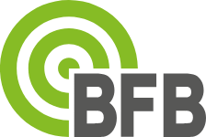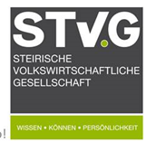 | Compulsory internship, holiday internship, diploma theses and company tours  are available at all establishments on request.
Goals of MINT:

- Breaking down inhibitions: STEM makes subjects accessible and helps to overcome fears and uncertainties in order to arouse interest.

- Promotion of interest and skills: STEM strengthens interest in science, technology, engineering and mathematics and promotes important skills for the future.

- Career prospects: Pupils gain insights into various STEM professions and learn about the many possible applications of these areas, which helps them to find their professional direction.

- Independence and teamwork: STEM promotes both independent work and teamwork, which teaches important skills for professional life.

- Practice-oriented learning: Through practical projects and experiments, knowledge is applied directly, which deepens understanding and makes lessons exciting.

- Early career orientation: Pupils gain insights into companies and their fields of activity at an early stage, which helps them to discover their professional interests and develop realistic ideas about future careers.

